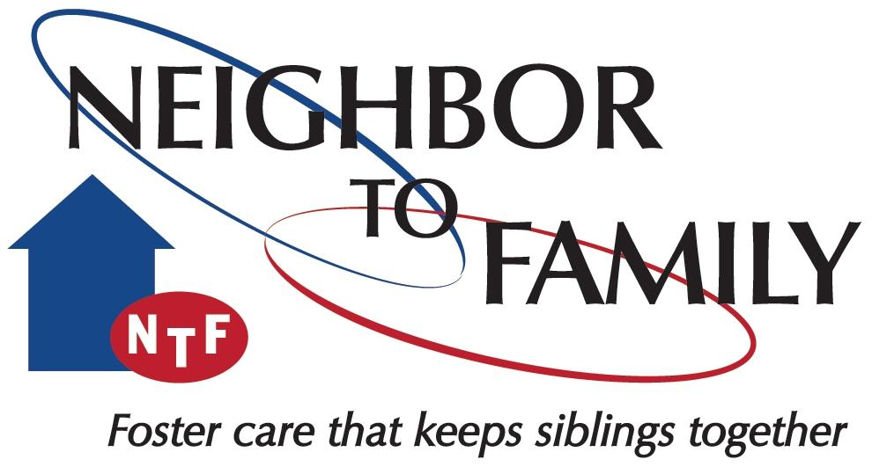

FATHERHOOD ENGAGEMENT SERVICES

GOALS:

The goals of services is to build relationships with fathers, help identify the needs of fathers, and assist fathers in accessing services

WHAT SERVICES LOOK LIKE:

Fatherhood Engagement Services promote engagement and responsible fatherhood through the provision of direct services. Services will educate, inspire and guide fathers toward working to meet dependency case plan requirements and an awareness of their worth as fathers within their families and communities. Through a needs assessment, services will help fathers identify and address barriers to being involved and effective fathers. NTF will communicate and coordinate with the Case Management Organization (CMO) to determine the status of the father’s referral and engagement with court-ordered services as well as any other needs as based upon identified barriers.

Services are administered through a Neighbor to Family (NTF) Fatherhood Engagement Specialist. This individual possesses the Florida Child Welfare Certification.

EVIDENCED BASED PRACTICES:

Neighbor to Family will utilize one of two evidenced-based parenting programs: 24/7 DAD® or Nurturing Parenting®.

Research has shown that the cycles of abuse and neglect can be replaced with new cycles of empathy and nurturing. Nurturing Parenting® is built on the premise that the maltreatment of children can be treated and prevented through the systematic application of family based programs designed to replace old and unwanted and hurtful patterns of parenting with newer, healthier patterns.

24/7 DAD® is built on the basis that fathers can be nurturers, and for men, nurturing is a learned skill. Through the program, men examine their own fatherhood history and the 5 traits of a 24/7 DAD® (Self-Awareness, Caring For Self, Fathering Skills, Parenting Skills and Relationship Skills)

HOW TO REFER:

Complete the NTF Fatherhood Engagement Services referral

